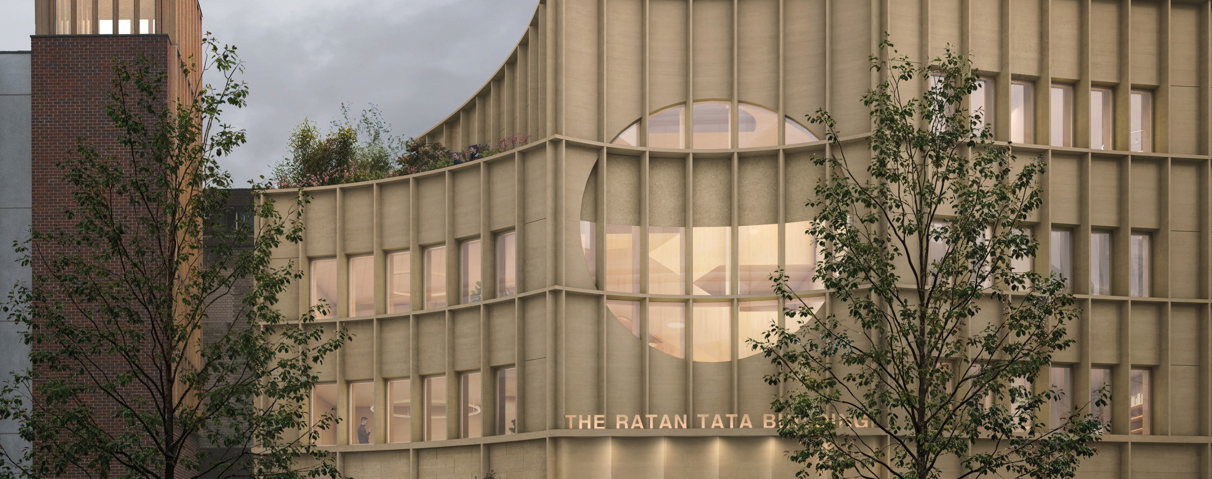

Ratan Tata Building – Weekly look ahead

Site Manager:

4th May 2026

Site Enabling Works

 |  | Involves |  |  |  |  |  |  |  |  |  | High | Medium | Low
 |  |  | Heavy Plant & Equipment | Light Plant & Equipment | Noise | Emissions | Dust | Constant | Frequent | Occasional | One Oﬀ | High | Medium | Low
Monday
 | Bank Holiday – Site closed
Tuesday | Removing Pavers for service trenches |  |  | X | X |  | X |  |  | X
 | Service trench excavations |  |  | X | X |  | X |  |  | X
 | Archaeology attendance
 | Muck away truck | X |  |  | X | X |  |  |  | X
 | Remedial works to nursery / Screen |  |  | X | X |  |  |  |  | X
Wednesday | Removing Pavers for service trenches |  |  | X | X |  | X |  |  | X
 | Service trench excavations
 | Archaeology attendance
 | Muck away truck | X |  |  | X | X |  |  |  | X
 | Remedial works to nursery / Screen |  |  | X | X |  |  |  |  | X
Thursday | Removing Pavers for service trenches |  |  | X | X |  | X |  |  | X
 | Service trench excavations
 | Archaeology attendance
 | Muck away truck | X |  |  | X | X |  |  |  | X
 | Remedial works to nursery / Screen |  |  | X | X |  |  |  |  | X
Friday | Removing Pavers for service trenches |  |  | X | X |  | X |  |  | X
 | Service trench excavations
 | Archaeology attendance
 | Muck away truck | X |  |  | X | X |  |  |  | X
 | Remedial works to nursery / Screen |  |  | X | X |  |  |  |  | X
Site Working Hours are from 08.00hrs to 17.00hrs - Monday to Friday
No Engines to Start on site before 08.00hrs
Red noise levels likely to cause disturbance
Orange medium levels of noise, occasionally intrusive
Green noise levels unlikely to cause disturbance

