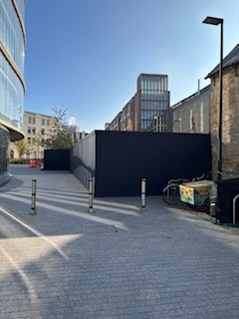

A weekly disturbance matrix will be sent out to notify all parties of any disruptive or noisy periods.

For any further Information on the Project please contact Martin Clarke
Tel: 07398 568029
email martin.clarke@kingerlee.co.uk

Works commenced to the Rata Tata Project on 13th April 2026. Since then, the team have stablished a secure site compound, with hoardings erected to the perimeter of the site.

With the compound installed, the team has been able to start the necessary investigation works to enable the project to proceed.

The shrubbery has been cleared to allow the old college wall along the Somerville boundary to be surveyed for Oxford City Council archaeological records.

There has also been a series of ground investigations to the building footprint to help inform the final structural design.

The next element of works will be to complete several service diversions. To prepare for this, the pavers will need to be lifted to allow the underground services to be fully identified and moved out of the way to allow the new piled foundations.

The enabling works will continue over the next 4-6 weeks, and will include the addition of several new drainage connections and service connections. Once the service diversions are completed, the site will be prepared for the piled foundation in July.
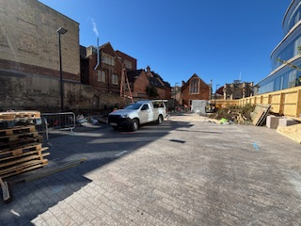
Date: 1st May 2026

