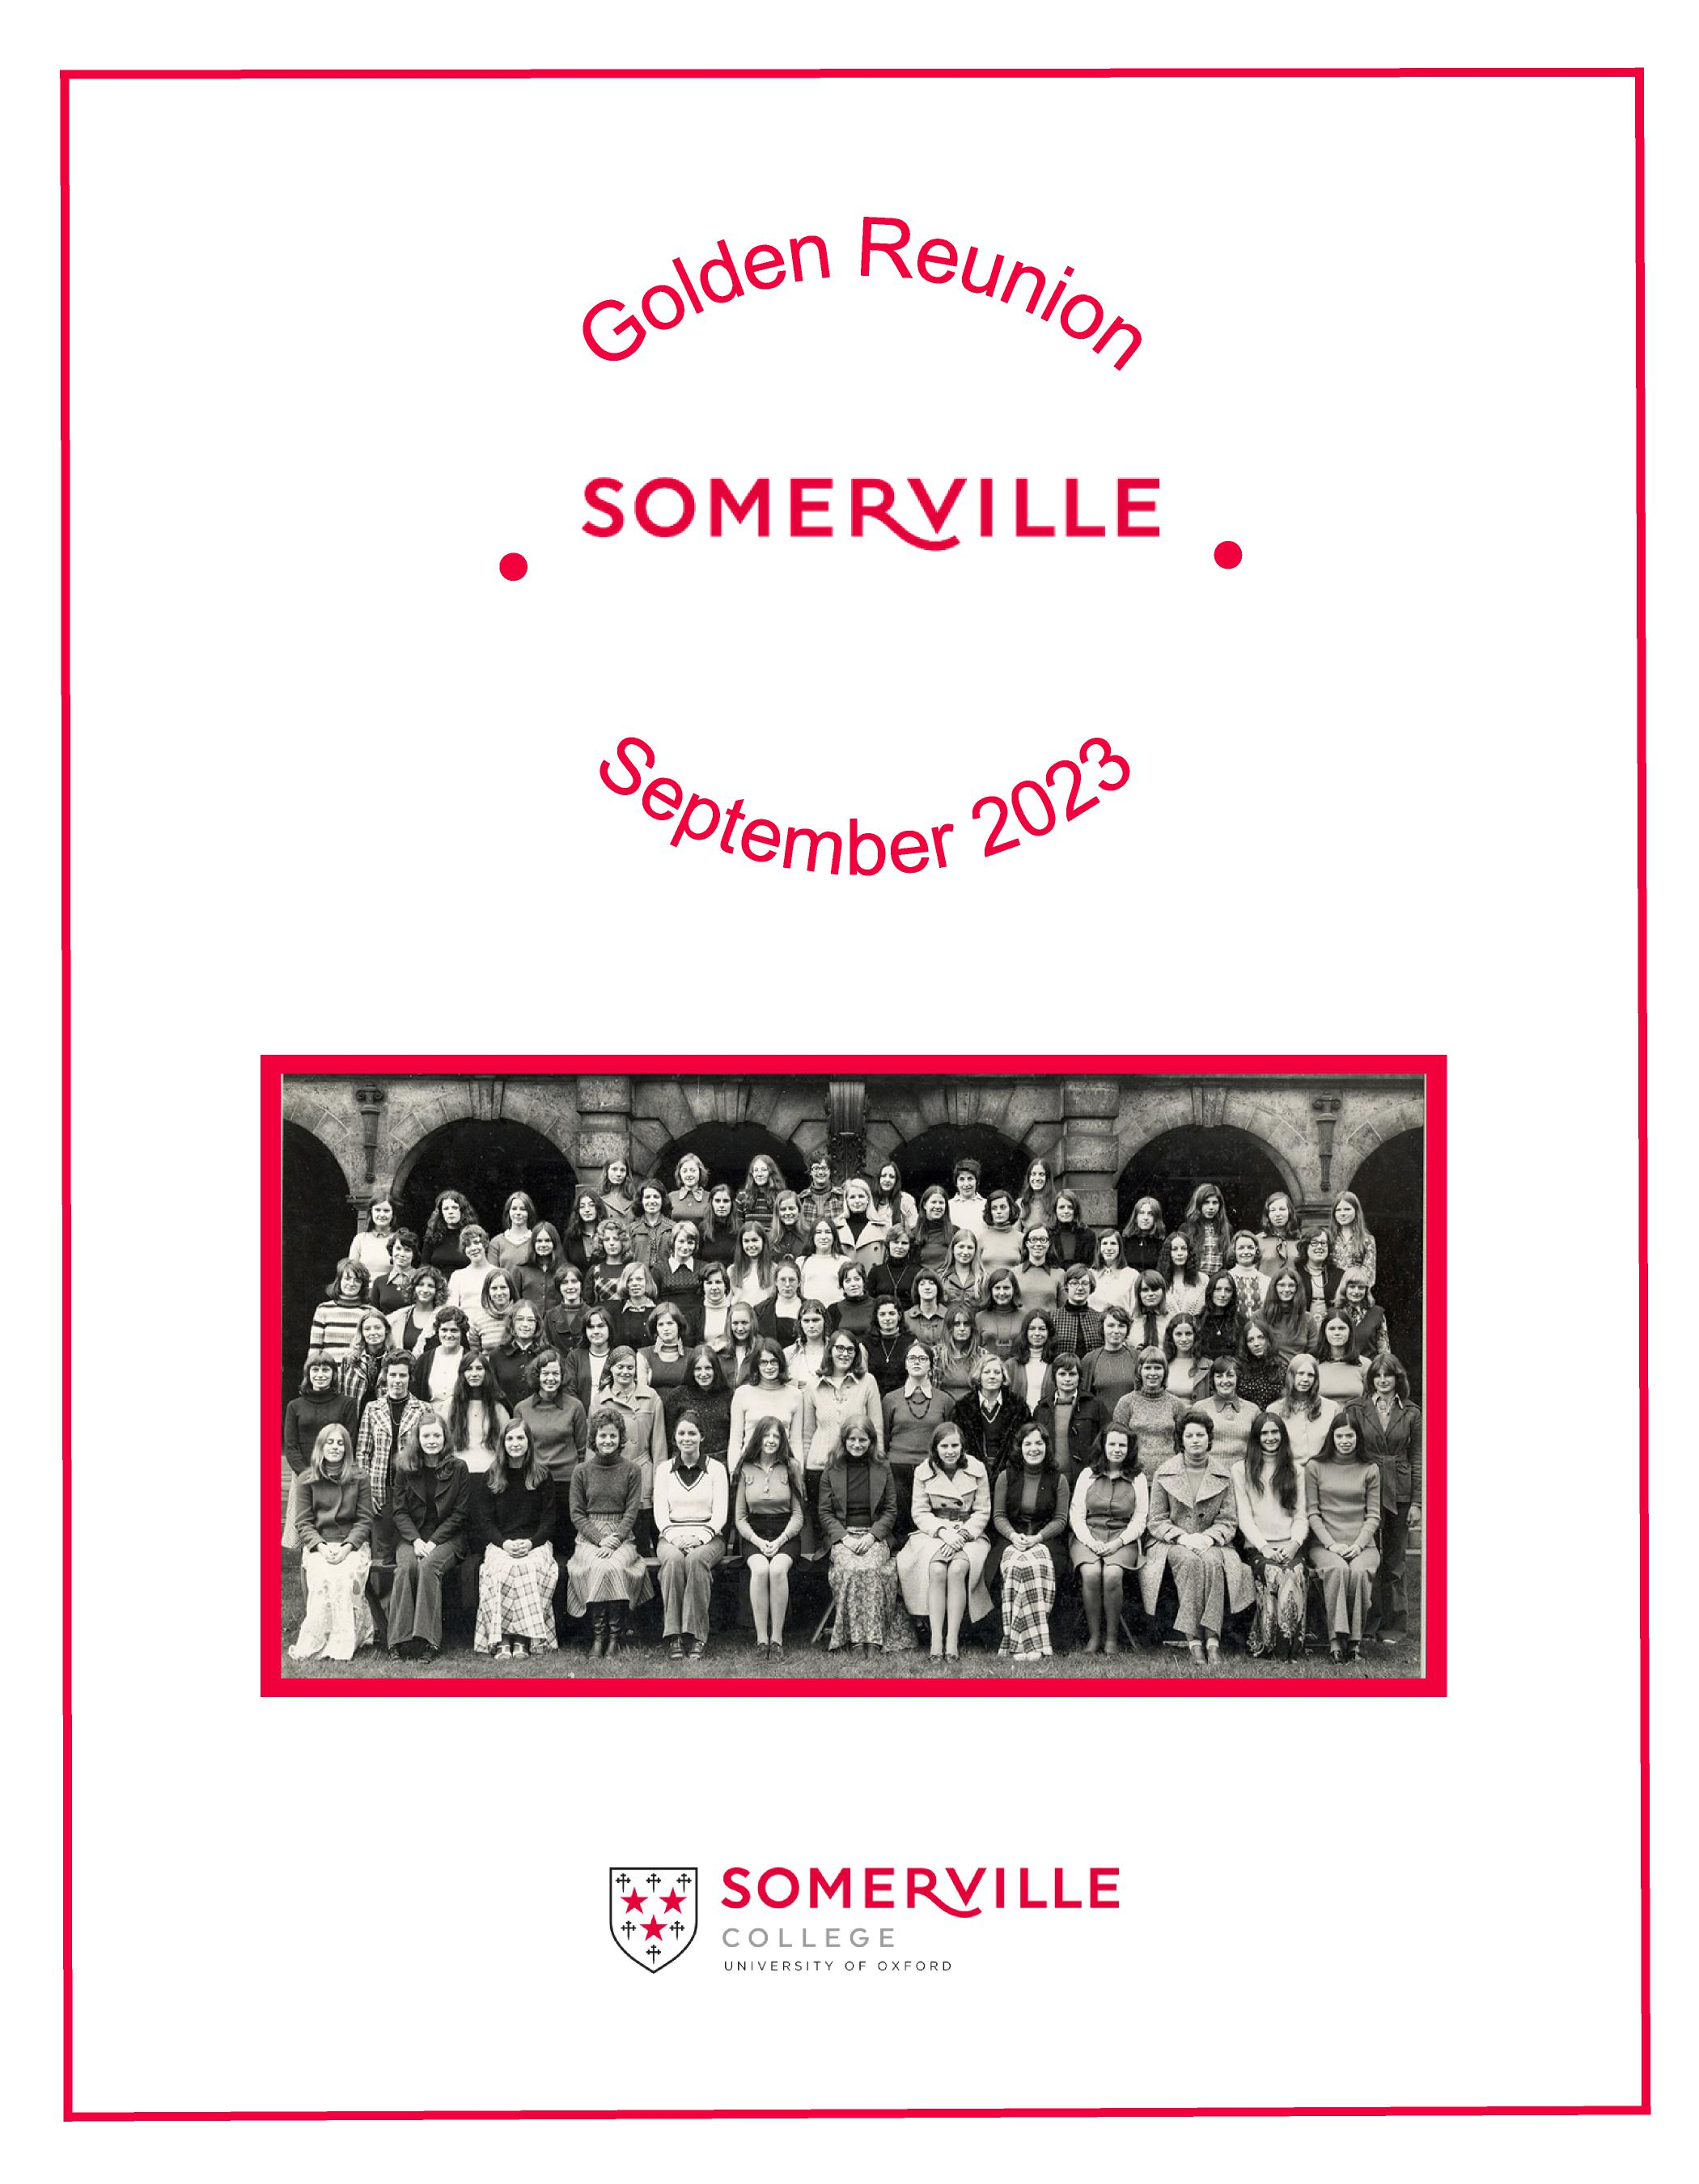

**1973**

**Somerville 1973 - 50 years on**

Thank you to everyone who sent a contribution to this booklet. It has been a privilege for us as the editors to read these as they arrived and to reflect on how varied our lives have been.

The more we read, the more convinced we became that no attempt at an editorial summary of how Somerville has affected our lives could do justice to their diversity.

We know that a typical Somervillian does not exist. One thing, however, that we as undergraduates had in common was that we were the last year group whose choice of Oxford colleges was limited to the then five women’s colleges of the university. In that respect at least we were a distinguished group.

We hope that you will be interested to read about the lives of our contemporaries and the different paths they have taken.

*Celia de Borchgrave d’Altena (Ogden)   
Anne Morton (Phillips)*

September 2023



|  |  |
| --- | --- |
| **Celia de Borchgrave d'Altena (Ogden)**  After three wonderful years at Somerville I went into publishing. I started at a small firm specialising in art books where the eponymous founder would treat us to cakes and ale in a good week. So Pergamon Press, where I moved afterwards, was rather a surprise: Robert Maxwell stalked the corridors of Headington Hill HQ seeking people to shout at and there was absolutely no question of cake. But the Journals department was a cheerful place and our Friday expeditions in search of CAMRA recommended ale were very educational. |  |

All this was interesting but not terribly useful experience for life in Bagdad, aged 29, as wife of the new Belgian Ambassador and mother of a 10-month-old. The country had suffered the brutal, repressive government of Sadaam Hussain’s Ba’ath party since ’79 and was reeling from three years of war with Iran. As diplomats we were protected from the worst horrors, but getting to grips with ambassadorial life, running an official residence and bringing up baby were complicated by food shortages, an Iraqi butler who was a police spy when he wasn’t breaking plates; an appalling chef shared with the Finnish ambassador; microphones scattered round the house and missile attacks aimed at the power station on the opposite bank of the Tigris which flowed past the end of our garden.

But we had basements which doubled as bomb shelters and storerooms for 6 freezers. And once we had the paperwork to hand over at military checkpoints we made expeditions to the shrines at Najaf and Karbala, to the Assyrian cities of Nineveh and Assur and to beautiful, haunting Babylon: all subsequently damaged by Sadaam or defaced, ransacked and blown up in the chaos following the US-led invasion or by extremist jihadists.

|  |  |
| --- | --- |
|  | We had five horribly interesting years in Bagdad, followed by a spell in Brussels and then two South American postings. Santiago de Chile immediately post-Pinochet was wonderfully peaceful and we all enjoyed it hugely. Lima, where we landed a few years later, was still seething with guérilla activity, so it was back to Kalashnikov-toting guards on the gates and other precautions which might have seemed excessive if a recent attack on the nearby TV station hadn’t blown out our windows and fractured the swimming pool. |

There was an agreeable garden which we shared with some pleasantly retiring vampire bats but the residence itself, although old and beautiful, was beset by poisonous spiders, rats, overmighty kitchen cockroaches and such determined termites that until the dining room floor was replaced we could only invite our weightier colleagues to dinner during the summer, when we could have tables in the garden.

|  |  |
| --- | --- |
| When my husband retired I retrained and enjoyed teaching ESL to adults. I have spent the last few years in Brussels looking after my husband, who died last year, and I will probably stay here. I rejoice in children, grandchildren, family and friends on both sides of the Channel and hopping back and forth on a Eurostar is ridiculously easy. |  |

**Virginia Covell (Hardman Lea)**

|  |  |
| --- | --- |
| I live in Kent with my husband Charles, to whom I was introduced by a close Somervillian friend forty six years ago! We enjoy the largely sunny and balmy climate here - such a contrast with the beautiful but damper and cooler North West, where we both grew up.  We also spend quite a bit of time in London where we are fortunate to be able to see our children Charlie and wife Lucy, who, to our delight are expecting a baby this summer and Katy and her partner Becky. I stopped work as a qualitative researcher some time ago and the opportunity arose to return to study at Greenwich University. |  |

I seized the chance to (legitimately!) spend time reading English literary texts and updating myself on Literary Theory. This combined well with family and domestic life and responsibilities and also gave rise to some entertaining moments e.g the shedding of tears of frustration at my inability to speed my glacial pace, when reading Nostromo and the incongruity of triumphantly reaching the end of Dombey and Son, for the Dickens course on holiday on a beach in Sicily.

The pleasure of learning has continued with attendance on a series of short courses (blessedly free of exams or homework) across a range of topics. Most recently I have been following a course in Moral and Political Philosophy - a subject I first became interested in at Somerville. Sporadic attempts to recapture competence in French and Italian, plus studying modern Greek complete my efforts.

Years ago I undertook a short course in Practical Gardening, but must admit that despite this, my gardening contribution is largely confined to aesthetic appreciation and learning Latin plant names, somewhat to my husband’s disappointment!

As well as all this “ self improvement” as a friend teasingly calls it, there has been time and opportunity for voluntary work of different kinds, ranging from supporting students learning English as a second language to acting as a guide at Sissinghurst, and before that, working at local and national level with a children’s healthcare charity. Serving on a number of Somerville alumni committees has always been interesting and rewarding.

This brings me to the importance of Somerville. The sense of being welcomed into a supportive but inspiringly challenging community began for me with the warmth of my tutors Mrs Roaf and Mrs Armstrong, when they interviewed me one dank and dismal autumn evening fifty years ago, and continues to this day.

|  |  |
| --- | --- |
|  |  |
| In 1973 Somerville represented both a safe haven and solid base for a young and unsophisticated undergraduate learning about the wider world and her place in it, while simultaneously trying to keep up with academic work and progress.  Additionally strong friendships were forged and conversations with fellow Somervillians were always stimulating and often challenging. Several of these friendships have deepened and flourished over the years. |
|  |

|  |  |
| --- | --- |
| **Barbara Habberjam**  I arrived at Somerville with a mixture of excitement and trepidation: excitement at the prospect of being a student at last after several months working as a hospital cleaner and trepidation at being a member of a women’s only College. After my Leeds grammar school (nominally single sex but involving plenty of interaction with the adjacent boys’ school) the idea of being part of women-only community was quite alien. Autumn 1973 was a heady and disorienting time for a fresher, opening with the occupation of the University Schools. |  |

Over the next three years balancing new friendships, political interests, and the demands of my course was at times challenging. But the experience of student life was easily positive enough for me to want to pursue it after I graduated by moving up the road to St Antony’s to do a B.Phil. in Russian and East European Studies.

A decision soon loomed: whether to convert to a D.Phil. or get a job. After much agonising, I applied for the Civil Service graduate entry scheme with no compelling motivation other than a vague idea of public service. Starting work in Millbank Tower (home of the then Department of Prices and Consumer Protection) was a real shock to the system and brought home just how lucky I ‘d been to spend five years in Oxford, surrounded by beauty and being funded to spend my time studying.

However, despite these initial doubts I ended up spending 37 years of my life in the Civil Service in several departments, including Trade and Industry and the Foreign Office. It was a career that offered immense variety, intellectual stimulation, and many civilised and sympathetic colleagues. It also introduced me to my future husband, whom I met (rather unromantically) on a course at the old civil service college in Sunningdale. The Civil Service has a justified reputation as an enlightened employer, offering flexible working and impressive development opportunities. Being able to work part-time for a few years relieved some of the pressure of raising our two children alongside demanding jobs. Highlights of my career were my two Foreign Office postings in its last decade, at our Embassies in Paris and Moscow, covering trade, investment, and economic affairs. It was a huge privilege to have direct access to politicians and business leaders and an inside view on the society and culture of the countries.

At Oxford I saw myself as a historian first and a linguist second, but that balance has changed over time. I have had continuing pleasure from being able to use and trying to improve my languages.

|  |  |
| --- | --- |
|  | I began doing some translation in my spare time in the 1980s. The arrival of our two children put an end to this, but living abroad encouraged me to return to translation after my retirement.  Life now combines looking after our little granddaughter, spending time in France, translating, and doing tours of the displays at the London Tate as a volunteer guide for the galleries. |

**Anne Morton (Phillips)**

|  |  |
| --- | --- |
|  | I arrived at Somerville with the gown and the cap belonging to my mother, who had matriculated at Somerville forty years earlier. I felt excited and proud to be following her example. In reading Jurisprudence (Law) I was also continuing a family tradition, as my father and grandfather were both lawyers.  Although I was not sure that I wanted to become a lawyer I knew that my degree would account for the first part of the qualifying exams. |

Having to read two hundred cases a week in some subjects was a challenge but it taught me how to absorb, retain, and later of necessity forget, important facts.

After I qualified as a solicitor I worked in London for a few years then changed career, settling for less stressful employment. Becoming a solicitor had actually been a good decision since I met my husband when we were doing our articles in the same firm.

We moved to Cambridgeshire, a relatively convenient commute for my husband to his law firm in London. We renovated a house, where we still live, and raised our son and our two daughters. I have been involved with various local activities and in the last few years have become a volunteer at our community-owned village shop.

I am not sure that I made the most of what Oxford had to offer, or probably what I was capable of, but I developed some confidence and, most importantly, made some lifelong friends.

**Krystyna Nowak**

I studied physics at Somerville, but will be the first to admit that rowing took up more time than physics. I enjoyed rowing in the blue boat in both 1975 and 1976.

Post Oxford I joined Citibank in London in the shipping department and then North Sea oil and gas project finance. I was the first woman in Citibank to return to work part time post maternity leave. In total I worked 19 years for Citibank, in London, Hong Kong and Singapore. We then returned to the UK via a couple of years in the Netherlands.

During these years I married StJohn Brown and we have three children - Alexander, Felicity and Eleanor.

A few years after returning to the UK I did a post graduate law degree and returned to work in a different sphere.

I started in board search, head hunting for Chairs and Non Executive Directors, which I continue to do now.

I have just retired after nine years as a Trustee of London Youth Rowing - a charity which brings rowing into state schools in underprivileged areas.

|  |  |
| --- | --- |
| **Elizabeth Potter**  At my Somerville interview the comment was made that no one had ever come to Somerville from Grantham. My reply was that only one person had previously done so: Margaret Thatcher.  Arriving at Somerville I was the shy, gauche country girl, lacking social confidence after a school career in seven different establishments, following my father’s peripatetic career around the country. Looking back, I did not take advantage of so much that Oxford had to offer but I gained many things. Friendships forged during those years of self-discovery have a unique lasting quality. |  |

Three years at Somerville provided a quiet confidence for entry into a legal profession at that stage very biased against women. The researching and writing of weekly essays was an excellent preparation for a subsequent judicial career.

The chance of being a solicitor in the National Coal Board when the Miners’ Strike broke turned me into an employment lawyer. I was recruited from there to Farrer & Co, not realising that this was in readiness for the Wapping Dispute. After an eighties of industrial strife the nineties seemed tame professionally so I decided to seek new challenges as an Employment Judge. I thoroughly enjoyed over twenty years as a judge and then the Regional Employment Judge in Central London. Legal developments in areas like discrimination law and the gig economy were intellectually stimulating and the practical challenges of trying to deliver timely justice in a cash-starved system were enormous.

I had a child and married, gaining five stepchildren, at the beginning of my forties. The notion of giving up my career and the identity that it gave me did not arise but the juggling and compromises were significant. I worked in London, my husband was a medic in Oxford: a life split between the two locations has now operated for over thirty years. The juggling and the compromises got greater when my husband developed motor neurone disease. The next fourteen years added superintending a 24 hour care team to balancing family and professional life

|  |  |
| --- | --- |
|  | Now, as I look back at the last fifty years, I am grateful for the foundations Somerville laid for the fulfilling life I have enjoyed to date – and hope to enjoy for more years to come. In retrospect perhaps the most valuable lessons learned were adaptability and resilience, necessary to deal with the difficulties along the path of life, not foreseen with the optimism of youth. |

**Janet Rogers (Ersts)**

What do I remember?

*Of Somerville...*

Early morning cycling down to Christchurch Meadow to row inexpertly in the first Somerville eight (borrowed) for some years.

Reading the Sunday papers at the round (oval?) table in the JCR window, and then stepping out through that sash window into the quad to start the day.

Stirring the most enormous pan of scrambled eggs in the West kitchen after dancing up the High on May morning. *Of Chemistry...*

The maths lectures – the goldfish swimming round and round in the large water flask used with great ostentation by Dr Abrahams for his mid-lecture refreshment. And the streaker (male), his details protected only by a briefcase, running down and along and up and out, through the lecture theatre. Both a very welcome antidote to the maths.

Days of organic practicals in the Dyson Perrins with Muriel, with only a hot chocolate, sitting on the cold stone steps outside the lab, for lunch. And the very helpful demonstrator who supplied some of the necessary chemical when my whole day’s careful efforts produced zero end product.

A hard-working but fun Part II year in Mike Pilling’s lab in the Physical Chemistry Lab – cycling in at midnight to the computer centre to see if my tape and card inputs(!) had finally reached the head of the cafe queue to give me some results. And cycling back from the PCL past the Jubilee street parties to write my Part II thesis. And meeting my ‘partner for life’ (so far!).

*And beyond Somerville?...*

I went to London (as we did) and started training as a Patent Agent – a good choice for a literate scientist, and it went well. The

offices were Dickensian – either side of Chancery Lane, one and a half rooms on each of 4 floors, oil lamps on the filing cabinets, ‘just in case’, a pint of milk for each employee every day, and a weekly hand towel each. It was a great experience, but it was rather sedentary and I had itchy feet.

So I found myself working in Research and Development at Kodak, focussing on graphic materials for the printing industry – technologies now totally superseded, of course.

We ‘escaped to the country’ (North Somerset) in the late 80’s, and after more R&D work, I decided to change direction and did an MSc in Parallel Programming (the principles underpinning most of Artificial Intelligence), during which, on the ‘best laid plans...’ principle, our daughter arrived, unexpected but hugely welcomed.

That led eventually to teaching – secondary science, after a PGCE, and a range of modules with the Open University, from STEM access courses to Level 3 ‘AI for Technology’ and similar. So by day I was teaching/mentoring in schools, but also with non school attenders. And in the evening/weekends it was the basics of maths and science etc. to foothill learners of all ages, interspersed with high-falutin’ AI topics to nearly-graduated learners, again of all ages.

And two years ago we retired (sort of) to South Somerset, and are settling into our new life with enthusiasm.

So, what did Somerville and Oxford do for me? Well, as a scientist I can’t really tell, as of course I have no control experimental results for comparison. But I think it gave me the confidence to ‘be myself’, and sent me off into a career, more ‘rag bag’ than ‘portfolio’, which has nevertheless sustained me. And I met many interesting people and made lifelong friends – a success in itself!