St. Paul's Nursery

Somerville College

119A Walton Street

##### Oxford



<Tel:01865270686>

**Email:** [**nursery@some.ox.ac.uk**](mailto:nursery@some.ox.ac.uk)

**Welcome!**

We understand that selecting the right childcare is an important decision for you and your child. At St Paul’s we always put the needs of children in our care first, ensuring there is a balance between play and learning.

**Introduction**

Somerville College was the first Oxford college to offer child-care facilities, thanks to the foresight and originality of the Nobel prize-winning Chemist Dorothy Hodgkin. During her years at Somerville, Hodgkin saw for herself the clear need for women to have childcare provision in order to work unimpeded. Today, Somerville remains one of the few colleges to offer childcare to its academics and postgraduates.

St Paul’s Nursery is a 16-place day nursery that caters for children between the ages of 3 months and 5 years. The Nursery was established as a work place nursery for the staff of Somerville College, but now opens its doors to children whose parents work elsewhere. The Nursery has a Management Committee made up of the Nursery Manager, the Domestic Bursar and three Fellows of the College. Priority is given to applications from Somervillian’s. Children must be brought to nursery any time within the first hour that the session starts. For example: by 9.45am for the morning and by 1.45pm for the afternoon.

Parents are requested to pick their children up promptly at the end of their child’s session; we do have a late collection fee. A late collection fee of £10 charged from the first minute you are late and then every 5 minutes after closing time.

The Nursery is open all year round except for two weeks at Christmas and all UK Bank Holidays.

The nursery runs a waiting list for applications that cannot be met at the time. The Nursery is able to care for 6 children under the age of 2 years and 10 children over the age of 2 years. The staffing ratios are in accordance with the Ofsted requirements, there are two members of staff working with the under 2s, giving a ratio of 1 adult to every 3 children. There are also two members of staff for the over 2s, giving a ratio of 1 adult to every 5 children. Members of staff are referred to as a key personand a list of the children allocated to each member of staff is on the notice board in the Nursery area.

The Nursery is registered with Ofsted and so undergoes regular inspections. The last inspection was carried out in February 2019 and the report was very positive, the report can be found on the Ofsted website.

The Nursery is also registered to accept funding for the education of three and four- year-olds, which is given to parents by the government to help cover the costs of childcare.

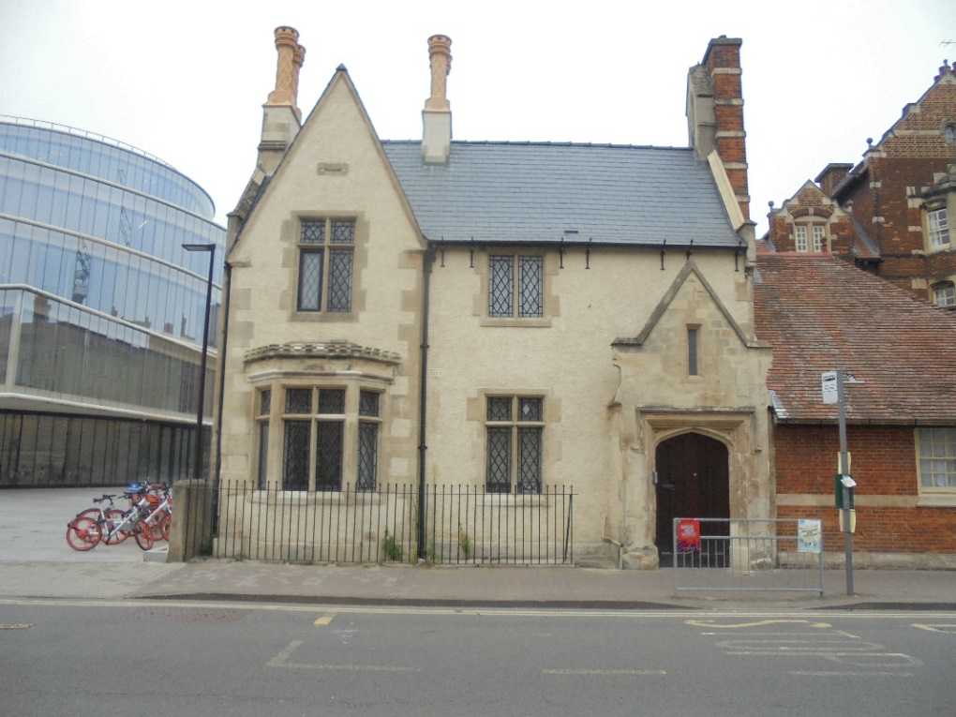

**The Aims and Objectives of the Nursery**

We at St. Pauls believe that all children deserve the best possible start in life and support them to reach their full potential. Children develop quickly in the early years and this has a major impact on their future life chances. We believe by providing a safe, secure and happy environment which promotes teaching and learning for your child will provide the right foundation for good future progress throughout their school and life.

The nursery has a management committee made up of the Principal, nursery manager. There is also a nursery fellow, a member of the college’s governing body (usually a parent from the nursery community), that has overall responsibility for leading the committee in supporting the nursery.

**Our vision**

We have a clear understanding that each child is unique in their individual needs and learning, as well as achievements. High expectations and challenges are set for all children

and risk play is encouraged within a safe environment.

This is promoted by “emerging” the children into the immediate local community and all available experiences.

Parents are invited to contribute to their child’s learning process, by sharing what learning takes place at home and what they would like their child to learn. We are keen to build the strong foundations of school readiness by promoting resilience, self-confidence and independence.

**The Staff**

There are seven members of staff currently working in the Nursery, all employed by Somerville College. Six staff members hold the appropriate childcare qualifications, while one is in the process of completing their qualification.

New staff members will not be left unsupervised until the disclosure and Barring Service has cleared all checks.

# The Facilities

St. Paul's Nursery is housed in one of the many Somerville College buildings. Access to the Nursery is from Walton Street but there is also an emergency exit into the grounds of the College.

The Nursery is comprised of a nursery office, one main room, a bathroom, and a kitchen; there is also an outside play area. The main room has two sections: an area for the under 2’s and an area for the over 2’s.

The outside area has colourful soft surface and is set up each day in accordance with our outdoor rota to incorporate all areas of learning. We have several bikes and tricycles, a large sand pit, wooden stools, a water tray and a treasure chest full of balls, bats, hoops etc. The garden has an outdoor shade covering half the garden to ensure the children can play outside in all weathers. We believe the outdoor area is a very valuable leaning place and it is important that the children have enjoyable experiences outdoors. Developing their physical and sensory skills and promoting equality and diversity in an outside environment.

The Nursery has a door entry system with an intercom so that members of staff can ask who wishes to enter the building. There is also a second lock on the Nursery door, inside the building, as extra security and members of staff can use a spy hole to identify who is at the door. A password system is used for carers/parents we have not met before.

The children have their own pegs to place all their coats and bags, and a storage area for prams and buggies/pushchairs, **which must be folded.**

**Parents partnership**

We fully acknowledge that parents are the first educators and we are pleased to welcome prospective parents to look around the nursery to talk to the staff.

Once the application has been approved and a place has been allocated, we have a settling in period which comprises a series of visits before your child starts so that they can become familiar with the nursery and the staff. We also discuss your child’s learning through play, likes, dislikes and routines.

On the second visit we encourage you to leave your child for a short time with their key person who will care for them.

Starting nursery is a big step in the development of any child, learning to detach from the main carers, cope without Mum and Dad, socialising with other children of different ages and accepting other adults, as well as learning the nursery routine (meal times, sleep, play, etc)

We recognise that every parents, carer, grandparent and friend of a child will have a valuable skill set that we can use at the nursery to enrich the learning experience of every child. Therefore, we encourage regular interactions within the nursery, by contributing to a new topic or activity, reading a story, cooking, planting or sharing their own special interest with the children.

Members of staff are keen to develop friendly contact and liaison with parents of the children in their care at all times. Learning is a partnership between home and nursery and it is important for the children that we work together to promote their learning. This contact is also important for the continued happy atmosphere in the Nursery.

Parents are encouraged to develop a positive relationship with the Nursery staff, as this will encourage the child to feel happier spending time with us. Parents are kept informed on a daily basis regarding their child's well-being and progress in the Nursery. This is achieved through conversation with their child's key person. Observations, planning, next steps and

assessments are completed at regular intervals for all the children by the child’s Key person, which parents can access through IConnect parent zone. Parents’ Meetings will be held at regular intervals and the Manager/Key person is always available to discuss matters relating to a child on an informal basis and on a more formal basis at a mutually convenient time.

**Key Person**

Each child in the nursery is assigned a key person. A key person has special responsibilities for working with a small number of children, giving them the reassurance to feel safe and cared for and for building relationships with their parents. A key person will help your baby or child to become familiar with the nursery and to feel confident and safe within it. They will also talk to parents to make sure that the needs of your child are being met appropriately, and that records of development and progress is shared with you.

**Food and drink**

St. Paul’s nursery is committed to providing healthy, nutritious and tasty food and drinks for the children throughout the day.

Members of staff also have Basic Food Hygiene training, First Aid training and Basic Health & Safety Training.

We recognise the importance of healthy eating and a balanced nutritious diet. We respect and cater for cultural and medical dietary requirements.

Please **do not** bring in food to the nursery building **due to allergies** this includes drop off and collection. If you wish to provide a celebratory cake please speak to your child’s key person who can advise on any allergies. **Our nursery is a nut free zone. Please be mindful when choosing to bring in cakes.**

**Safeguarding Children and Security**

All members of staff have DBS clearance checks showing that they have no record of offences that could affect the safety of the children. All staff have current recommend training for all areas of safeguarding as this is of importance to us and for the safeguarding of our children’s here at St Pauls. Any temporary members of staff that are employed also have clearance sought by the College or the agency they work for. Students carrying out a placement in the Nursery are not left unsupervised with the children.

We have a mobile phone policy here at St Pauls, which states **no** Mobile phones or smart watches are to be used in the playrooms or garden by staff parents and all visitors.

Confidential records and information regarding staff and children will be held securely and only accessible and available to those who have a right and need to see them. We are aware of our rights under Data Protection and the General Data Protection Regulation and when appropriate Freedom of information Act 2000.

**Special Educational Needs**

We provide an environment in which all children, including those with special education needs, are supported to reach their full potential.

Payment Arrangements

Invoices are prepared monthly in arrears, with the payment due two weeks from the date of the invoice. Cheques should be made payable to Somerville College.

There is a salary sacrifice scheme available for Somerville College and university employees, and they can request further details on the scheme from the Somerville College, Treasury Department.

# Health and Illness

St Paul’s Nursery only accepts children with the MMR vaccination.

We have a responsibility to other parents to protect their children as far as is possible, and parents are requested to respect the health of other children by keeping their child away from the Nursery when they are obviously unwell.

**Our Illness procedures**

In order to take appropriate action of children who become ill and to minimise the spread of infection we implement the following procedures:

* When a child becomes sick during the nursery day, we contact their parent(s) and ask them to pick up their child as soon as possible.
* Once reading of high temperature of 37.7 and over has been taken, we will ask the parent or carer for their permission over the phone, before we will administer Calpol. If within 30 min. to 1h the temperature reading is not lower, we will ring the parent to collect their child and seek medical advise. During this time we care for the child in a quiet, calm area with their key person, wherever possible.

# We follow the guidance given to us by Public Health England (Health Protection in Schools and other childcare facilities) <https://www.publichealth.hscni.net/sites/default/files/Guidance_on_infection_control_in%20schools_poster.pdf> and advice from our local health protection unit on exclusion times for specific illnesses. No child should be brought into nursery if they are unwell. We will not be able to accept children who are suffering sickness and diarrhoea, measles and chicken pox, in order to protect other children.

* Have an infectious disease, such as sickness and diarrhoea, they must not return to nursery until they have been clear for at least 48 hours. We inform all parents if there is a contagious infection identified in the nursery, to enable them to spot the early signs of this illness. We thoroughly clean and sterilise all equipment and resources that may have come into contact with a contagious child to reduce the spread of infection
* We notify Ofsted as soon as possible and in all cases within 14 days of the incident where we have any child or staff member with food poisoning.
* We exclude children on antibiotics for the first 24 hours of the course (unless this is part of an ongoing care plan to treat individual medical conditions e.g. asthma and the child is not unwell in addition, we will administer antibiotics if the child has had them before.) The child must be well enough to be able to cope with the nursery day and be part of a group. This is because it is important that children are not subjected to the rigours of the nursery day, which requires socialising with other children and being part of a group setting, when they have first become ill and require a course of antibiotics
* We have the right to refuse admission to a child who is unwell. This decision will be taken by the manager on duty and is non-negotiable.

**Learning through play**

We recognise that children learn best through play. And every child has the right to play as stated in The United Nations the right s of children 1989

Play is vital for a child’s overall development both physically and mentally. Structured play and free, unrestricted play with no adult interference, will stimulate children’s imagination and overall well-being.

Allowing children to take risk and challenge themselves through play is important in developing resilience and self-confidence.

We are also mindful of ensuring that each staff member feels fully involved, happy and valued in the setting.

Our practice and principles focus on

* Child initiate/adult led learning
* Outdoor education and connecting children with the natural world
* Being able to take and manage risks, in order to develop and strengthen self-confidence
* Adopting a holistic approach with every single child and their family
* A nursery environment that offers a creative and stimulating learning experience
* When children play they are using their bodies, minds and emotions to build up the knowledge, skills and attitudes that will remain with them for the rest of their lives. Play, indoor and outdoor, is essential for the children’s healthy development. They make choices, follow their interest, ask questions and practice their skills. Through playing with others they learn how to manage their feelings and become confident about themselves and their abilities. Children who have these opportunities to become independent learners are better equipped to master more formal approaches to reading, writing and maths.
* Being willing to explore and experiment
* Making choices and decisions
* Finding solutions to problems independently
* Concentrating to a task and having a positive attitude towards challenges
* Playing cooperatively with other children and adults
* Beginning to understand the feelings and views of other people

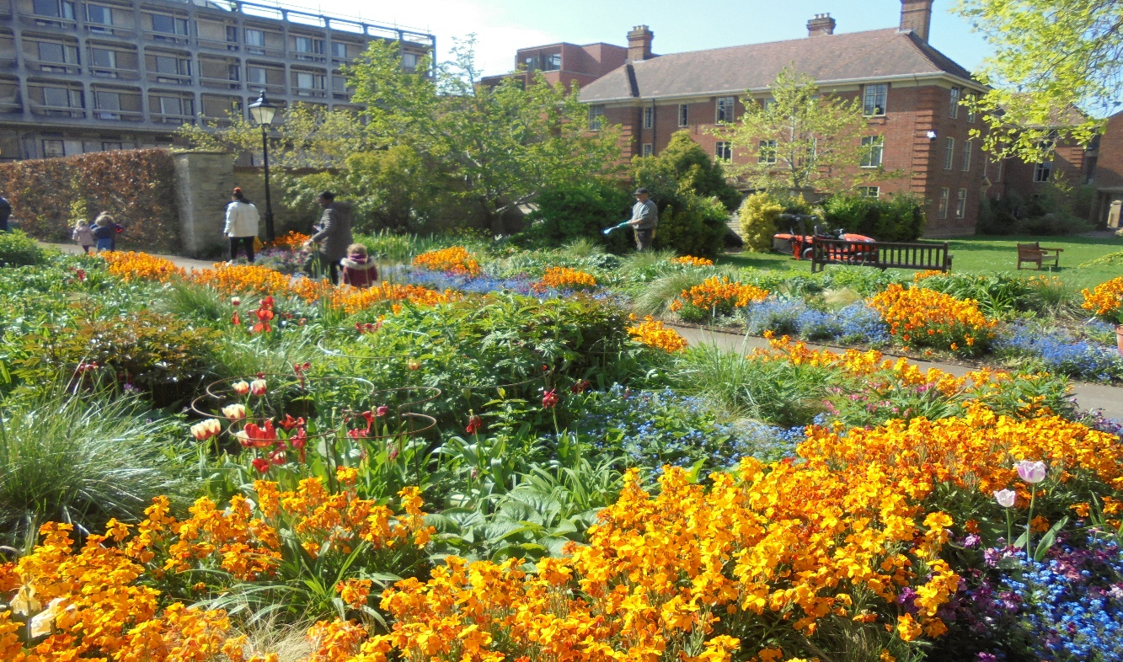

**(EAL) English as additional language**

As a university nursery we welcome many international children where English is an additional language. If a child starts with no knowledge of English we monitor them carefully. Some children settle into the environment and are happy to pick up spoken English from other children and staff. Other children might find the new language and the environment more of a barrier in which case we introduce measures:

Longer settling in period

Key/relevant words from native language and personal family environment

It may be helpful to introduce a picture exchange communication system, individual to the child.

Working with the child at their own pace is essential

We will be in constant communication with parents and discuss progress

We will always uphold the child’s first language and cultural identity

**Clothing**

During the course of their nursery session, your child will explore and experiment with different kind of materials, including messy ones. You are advised to send your child in practical clothes rather than very smart or expensive ones.

We also ask parents to bring a spare set of clothes and underclothes just in case. These are kept in a bag provided on your child’s own peg in the entrance hall. We provide aprons for painting, water play and messy activities as clay, gluing and junk modelling.

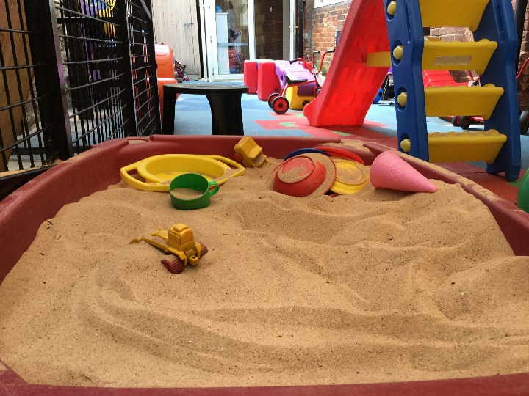 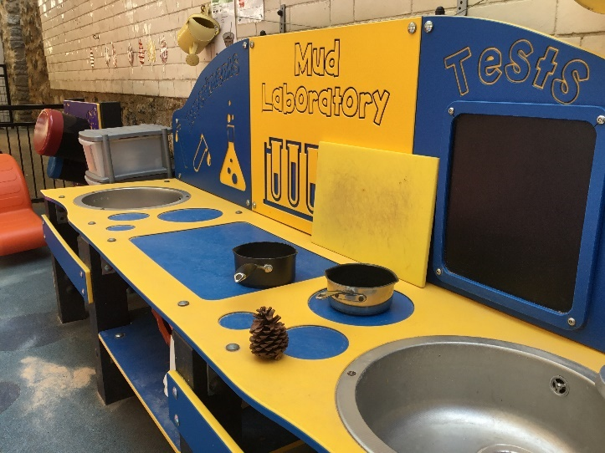

**Toilet training**

Extra spare cloths will be needed when you feel your child is ready for toilet training. Nursery staff can advise on toilet training but no one knows your child better than you.

The nursery will support your decision to start toilet training or to wait for a later date.

We strongly recommend that children who are in the process of toilet training wear clothes that are easy to remove, no jeans belts or braces, as this encourages self-help skills and independence. Although a staff member will always be on hand to help.

If you wish for your child to use a potty, the nursery will be able to provide one or if you prefer to bring your own from home.

**Nappies**

We ask you to provide nappies and cream for your child while at nursery. The nursery will make sure your child is clean and comfortable throughout the day.

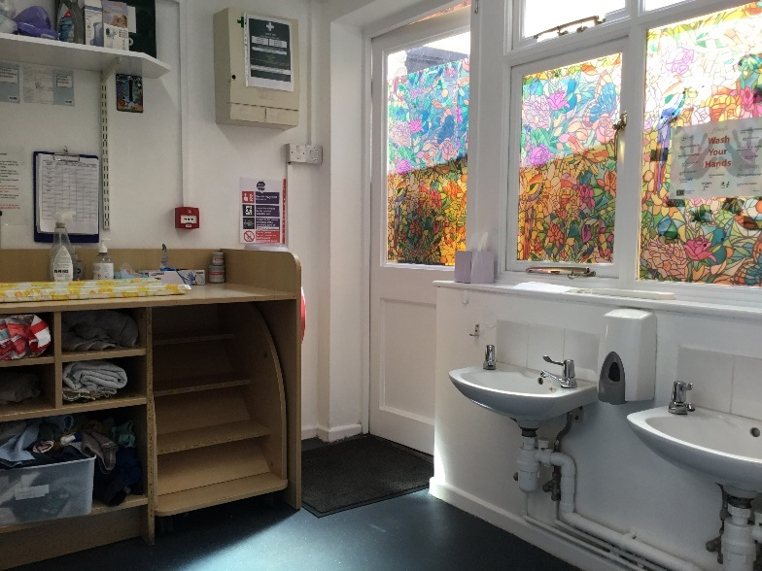

**Sleep time**

Young children’s sleep routine will be respected at the nursery and a separate sleep room is made available. Older children will have the chance to sleep should they feel tired or need the afternoon sleep, between 1-2.30pm.

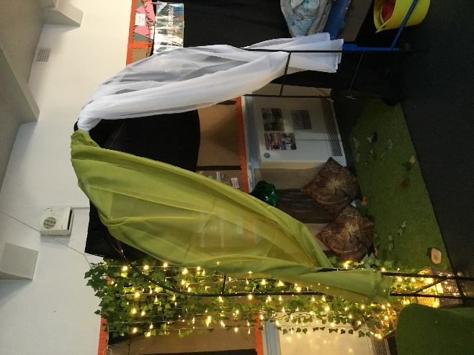 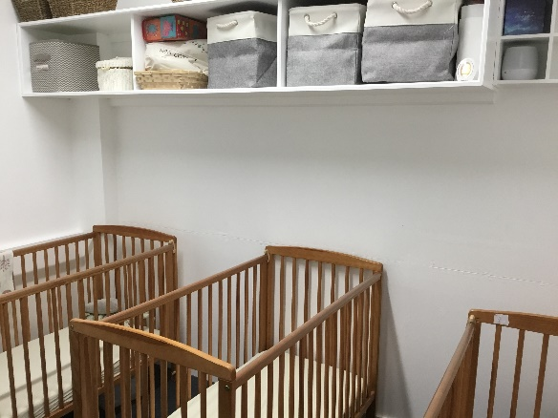

**Child collection**

The nursery requires contact details of parents and authorised adults who are able to collect their child. Parents must set up a password at enrolment, that would be used when other authorised adults are collecting the child. A photograph of the person collecting should be provided.

In the event of a child not being collected by an authorised person, please refer to our Child Collection Policy.

**Admission policy (amended from 1st January 2022)**

We offer Full 5 Days and 5 mornings or 5 afternoons and two or three consecutive days.

Having read this booklet and would like to enquire about a place for your child please contact the nursery on this number on 01865 270686 or email the nursery [nursery@some.ox.ac.uk](mailto:nursery@some.ox.ac.uk)

You will be given an application form and be told what the availability is like; if there is a space for your child, we will then arrange a visit for you to view the nursery. The application form should be returned when you have decided to apply for a place. Your child's name will then be added to the waiting list and we will contact you when we are able to offer you a start date.

**Deposits**

At St Paul’s nursery, we do require a deposit. This is £500. This is to secure and hold you place until your child starts. The deposit will be returned to you at the end of your child’s time with us. If you choose **not** to take, the place and we have saved this place for your child the deposit will **not** be refunded to you. We also need 2 months’ notice to terminate your place here at St Pauls. We can only defer your child’s start date for 3 months.

**Sessions**

Once we have agreed the sessions in writing these will be yours throughout your child’s time with us. If you wish to decrease your child’s sessions this does require 2 months’ notice and this will be subject to availability. We endeavour to move your child to the older room once they have reached 2 -2 ½ years old; however, this will be subject to availability and cannot be guaranteed.

**Somervillian’s Only**

If your circumstances are such that you require us to keep your place open for more than 1 month we can do so, however you will be required to pay 50% of the monthly charge for your sessions booked and after 6 months, you will be asked to pay the full amount. This will guarantee your nursery place is kept open for you during your leave.

If you wish to terminate your place or reduce your sessions at the Nursery, we will require two months written notice.

If a **Somervillian** terminates employment with the college (no longer paid by Somerville) and wishes their child to remain in the nursery, their nursery fees will change accordingly to the Non-Somervillian rate.

Once your child has been given a place at St. Paul’s nursery, you will be given a registration document along with the parent policy document with all of our policies and procedures and the terms and conditions.

**Equality and Diversity**

St Paul’s Nursery welcomes equality and diversity and will uphold and promote inclusive principles for all children and families within our nursery.

Here at St. Paul’s nursery we embrace, celebrate and value all the similarities and differences that each individual family brings to the nursery.

Children’s learning is largely influenced by the ideas, attitudes and practices of those in close contact with them.

Staff are aware of the importance of developing ways of working and talking to children which provide positive attitudes and images towards individuals regardless of race, culture, religion, language, disability or sex/gender.

We strive to ensure that the Nursery environment is free from racist or sexist influences, and that the cultural and religious backgrounds of the children are respected.

We look forward to meeting you and your child in the future.

