Somerville College, Oxford

Admissions interview information (for Graduate-Entry Medicine applicants)

We hope you enjoy your stay at Somerville for admissions interviews. This document explains what you need to do before you arrive, and what will happen while you are here.

1) Before you arrive

The interview invitation email which you should have received specifies the date and time that interviews at Somerville will start for your course. It is important that you arrive at Somerville in good time to be ready by the time stated. If you are concerned about being able to reach Somerville on time on the day specified, you would be welcome to arrive the night before.

You are provided with free accommodation and meals at Somerville throughout the time you are required to be available for interviews.

Please immediately complete and return an Interview Arrival Form, which you can download from the College Web site at http://www.some.ox.ac.uk/undergraduate-admissions/.
On the form, let us know:
- estimated arrival and departure dates and times
- dietary requirements (due to allergies, medical conditions, religion, etc)
- other arrangements required, such as accommodation or interview-related arrangements (due to disability, health condition, religion, etc)

You may leave Oxford only once you have had all the interviews scheduled for you at two colleges. Details of these interviews will be available when you arrive at Somerville.

Please note that all Somerville premises, both indoors and outdoors, are non-smoking.

2) Arrival at Somerville

The College's front gate, on Woodstock Road, will be locked at 11.00 pm each evening. If you are delayed, and arrive after this time, you can ring the bell next to the front gate, and/or call the Porters’ Lodge (the reception in Woodstock Road) on + 44 (0)1865 270600, and someone will open the gate for you. Please also call the Porters’ Lodge as soon as you know you will be delayed, to give them an estimated time of arrival.

Information on how to get to Somerville is available on the College's Web site at: http://www.some.ox.ac.uk/contact-us/

Please note that no parking is available at Somerville. If you have mobility difficulties or other access requirements, please let us know.

3) While you're at Somerville

When you arrive, you should go to the Porters' Lodge. There, you will be given the key for your room, and an electronic access card to open doors into buildings.

Interview timetables will be available at the Admissions Hub in the House building. The Porters will be able to direct you there.

There is a map of Somerville on the back page, to help you find the buildings you need to go to.

Meals
Meals, free of charge, are available from the College's self-service Pantry, and eaten in the Dining Hall (across the corridor from the Pantry), at the times below:
Breakfast 7.45 – 9.00 am (Thursday 14 and Friday 15 December)
Lunch 12.30 pm – 1.30 pm (Wednesday 13 to Thursday 14 December)
Dinner 6.00 pm – 7.00 pm (Wednesday 13 to Thursday 14 December)

Lunch and dinner are both usually hot meals, with dessert available. Some soft and hot drinks are also available, in addition to drinking water. Confectionary is available from vending machines around the College. Our Catering department can accommodate a wide range of dietary requirements.

Accommodation
Your room will be available from 2pm on your arrival date.

Each applicant has his or her own single study-bedroom (free of charge), in an accommodation block on the College site. Bedding and a towel are provided. Bathroom facilities are shared between a number of bedrooms. Accommodation will be mixed (men and women may be in the same building but men are allocated bedrooms in a particular block or floor, with women allocated to other blocks/floors).

There are no rooms available with en-suite bathroom or toilet facilities.

Some administrative offices and tutors' teaching rooms are located in the same buildings as sleeping accommodation.

Fire alarm and fire regulations
The fire alarm is a loud siren. A fire regulations notice is posted in every bedroom; please make sure you are familiar with these instructions.

Telephones and Internet
If you expect any telephone messages, the number for callers to ring is + 44 (0)1865 270600. Internet access is provided for free by The Cloud. End-user help is available from The Cloud via http://www.thecloud.net/free-wifi/join-the-cloud/

Prayer room
A room suitable for prayer and quiet contemplation will be available to members of all faiths and none.

Welfare
We recognize that admissions interviews are stressful, and we want you to feel comfortable while at Somerville. During the day, College staff will be available in the Academic Office (House 4, ground floor of House building) and Student Helpers at the Admissions Hub. Outside office hours, the Porters may be reached at + 44 (0)1865 270600.

Security
Oxford is no more dangerous than other large towns, but as a general precaution, you are advised not to go out of College alone late at night. While you are with us in Oxford, we have a ‘duty of care’ to take reasonable steps for your safety. In light of the responsibility we have, we restrict access to College and try and encourage you to keep as close to home as possible. The College's front gate, on Woodstock Road, is locked at 11.00 pm each evening. If you are delayed, and arrive after this time, you can ring the bell next to the front gate, and/or call the Porters’ Lodge (the reception in Woodstock Road) on + 44 (0)1865 270600, and someone will open the gate for you. You are expected to stay in College for the minimum interview period for your subject, but if for any reason it is necessary for you to leave before this time, please let the porter know that you are leaving early when you hand in your room key, so that we do not become anxious about your whereabouts and can account for you in an emergency.

You will have received from the Porters' Lodge an electronic access card which will grant you access to the required buildings in College. It is important not to hold the door open to others when entering the building unless you know that they too have cards. It may seem rude, but tailgaters are a problem which can result in strangers gaining access and opportunities to steal. Your belongings are left entirely at your own risk anywhere in College and at any time. Please remember to lock your door and windows every time you leave your room.

Departure
You will be asked to vacate your room by 10.00 am on your departure date. It is important to do this, as your room may be needed for other guests. On the day that you depart, the Porters' Lodge will have facilities available for you to leave your belongings and freshen up if necessary.

Please return your keys and access card to the Lodge upon departure.

Outcome of applications

We will notify you of the outcome of your application on 10th January 2018.

If you wish the communication to be sent to you at an email address other than that you have given on your UCAS form, it is vital that you let us know before you leave Oxford, and preferably immediately. Please email admissions@some.ox.ac.uk with your full name, the course you are applying for, and your new details. This is particularly important for overseas applicants who are applying from UK schools.

Note that the outcome of applications will not be available over the telephone.

Good luck, and enjoy your stay!

The Academic Office
2nd November 2017
admissions@some.ox.ac.uk

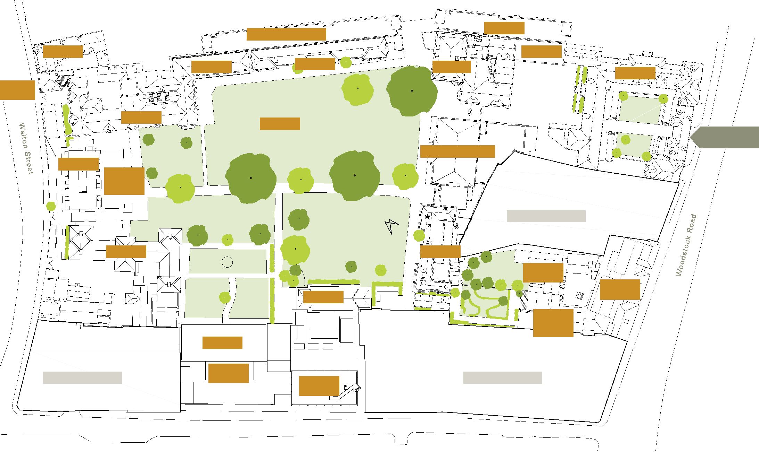
ROQ East
ROQ West
Nursery
Hostel
Holtby
Library
House
Darbishire
Park Lodge
Park
Main Quad
Main Entrance & Porters Lodge
Maitland Hall
Wolfson
Brittain-
Williams
Room
St Aloysius Church
Penrose
Maitland
Radcliffe House
Chapel
Dorothy Hodgkin
Margaret
Thatcher
Centre
Vaughan
Shops
The
Terrace
Margery Fry
Shops
Little Clarendon Street

