**John Fingleton, CEO Fingleton Associates**

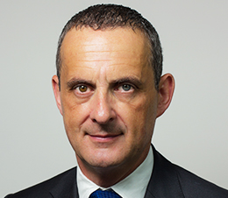

John Fingleton was Chief Executive of the Office of Fair Trading from 2005 to 2012, having previously run the Irish Competition Authority. John completed his doctorate at Nuffield College, Oxford and as an academic economist at the London School of Economics, Trinity College Dublin and the University of Chicago, he wrote about and taught game theory, economics of industry and regulation. In government, he oversaw merger regulation, enforcement of competition rules, consumer protection and credit regulation. He has been a strong advocate for the removal of government restrictions on competition and supply side reforms to improve productivity growth. John is a member of the World Economic Forum Council on Emerging Multinationals, a member of the Policy Advisory Board at the Social Market Foundation, Non-executive Board Member of StepChange, and a Trustee of the Kaleidoscope Trust.