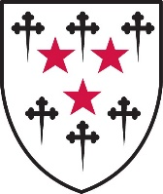
Somerville History Day
Sunday 23rd September 2018
Programme
Time | Event | Details
11:00am | Tea & Coffee in Flora Anderson Hall (Wolfson Building)
11:30am – 12:30am | History at Somerville | Benjamin Thompson: The evolving History curriculum  Faridah Zaman: Our new Fellow introduces herself  Jo Innes: Life after employment
12:30pm | Drinks Reception in the Mary Somerville Room (Old College Bar)
1:15 – 2:45pm | Lunch in Hall
2:45 – 3:45pm | Alumni networking session | The Uses of History: Education, Government and Media  A choice of three parallel sessions covering areas now inhabited by many Somerville historians, to enable you to meet others in similar occupations and exchange experiences and ideas. Fellows will moderate and we will ask some alumni to speak briefly to start the discussion, but all are welcome to attend and participate as they choose
3.45pm | Tea with strawberries and cream in the Marquee | Friends and family are invited to join for tea

