Traditional and local knowledge surrounding the role of legumes in soil fertility in India
Barbara Smith, Soumik Chatterjee, Parthib Basu
Centre for Agro-ecology and Pollination Studies, University of Calcutta, India

Legumes are nutritious and contribute to soil fertility, yet legume production is low amongst smallholder farmers in North East India. This study explored the underlying farmer perception and awareness that drives local decision-making for legume production. Local knowledge of legumes and their role in human nutrition and soil fertility was collected from 440 farmers across 30 villages in NE India. Farmers identified and ranked legumes they considered to be nutritious, palatable and available; 15 types of pulse were included in the local diet and famers considered commonly consumed pulses to be nutritious. Farmers did not make a strong link between legume cultivation and soil fertility. Legumes were not a priority crop. Potential interventions to encourage and increase legume production include: research into the role of legumes in improving soil fertility; training in crop husbandry and water management; new markets for legumes; improved supply of good quality seed; access to legume processing units. This work will contribute to the design of participatory research aimed at providing sustainable nutrition in rural communities.

Introduction

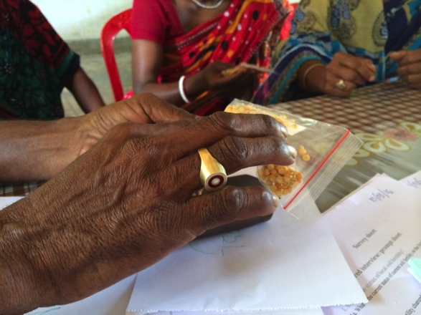
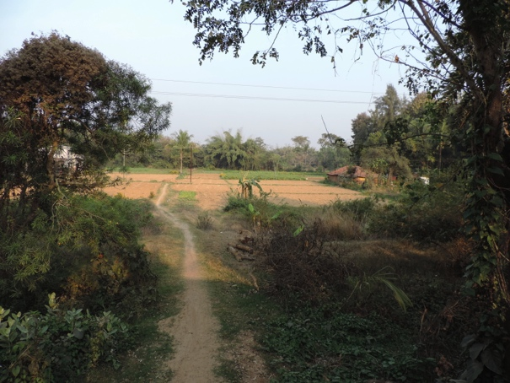
There is evidence that optimally managed leguminous species can support cropping systems by contributing positively to soil fertility (Crews and Peoples, 2004), as well being a highly nutritious food source providing essential amino acids and nutrients. Despite this, legume production in India has not kept pace with other crops. India is now the largest importer of pulses in the world - Indian imports of pulses increased 75% between 2005 and 2012. In an effort to mitigate the situation, all pulse exports, apart from ‘Kubuli chana’ (Cicer arietinum chickpea), have been banned since 2006. Given the multiple benefits of legumes it is surprising that they are not grown more extensively and successfully by smallholders. Although studies are underway to address the practical and agronomic barriers to increasing legume production (Ghosh et al., 2007), there has been no work on the local knowledge and underlying farmer perception and awareness that drives local decision-making for legume production in India. Increasingly it is recognised that there is an important role for local knowledge to inform decisions about the use of biodiversity and its management (Sutherland et al., 2013; Tengö et al., 2013). It is with this in mind that this study was devised.

The aim of the study was to collate local knowledge and explore the potential for increased legume production by small-holder farmers (Traore et al., 2012). The output will contribute to the design of participatory experiments aimed at providing sustainable nutrition in rural communities, potentially incorporating legumes. We used a case-study approach, carrying out our study in the State of Tripura, North East India. Tripura has poor soils of low nitrogen status (Pathak, 2010) coupled with low legume production and deficiencies in nutrition . In a nationwide study it was shown that 73% of households did not meet the Recommended Dietary Intake (RDI) of pulses and legumes and that this contributed to severe malnutrition, particularly of micronutrients, in rural areas (Arlappa et al., 2007).

The objectives of the study were to collate local knowledge on:
1) The role of legumes in the local food system including the role legumes play in local diets, the current extent of cultivation, together with opportunities and barriers for increased legume production.
2) The role of legumes in maintaining soil fertility on local farms

Method

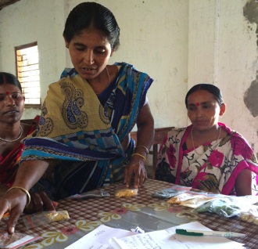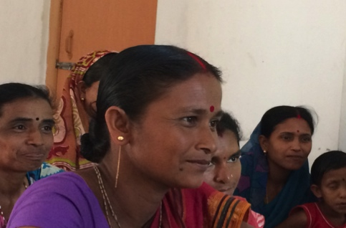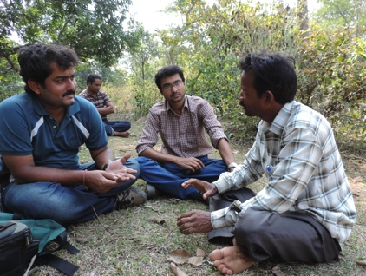

Using focus groups we surveyed 440 farmers in 30 villages in the NE state of Tripura. 19 villages were predominantly tribal while the remaining 11 were general caste. We used two approaches: 1) a pile sorting exercise where farmers identified, classified and ranked legumes according to how they perceived nutritional value, palatability, frequency of consumption and availability (Bernard, 2002). 2. Guided conversations that focused on soil fertility and understanding the role of legumes in local farming practice. .

Key results
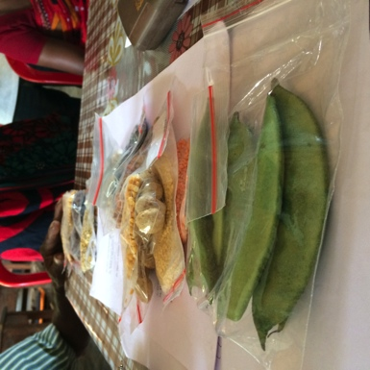
Red lentil was overwhelmingly the most popular pulse. It was eaten most days by the majority of participants, was considered to be the most nutritious of all the legumes and was readily available in local markets. After red lentil, the most commonly eaten pulses were, in order, as ranked by the farmers, soya bean, garden pea, green gram (mung bean), and Bengal gram (chickpea). In terms of nutritional value, farmers considered all of these to be nutritious but also ranked field beans and kidney beans very highly. 15 types of pulse were included in the local diet; farmers shared legume-based recipes with the team.

Soil fertility
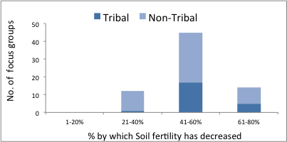
The majority of farmers believed that: soil fertility was declining; that this process was not recent but had been ongoing for between 20-40 years; that soil fertility had fallen dramatically (Fig.1). However farmers did not make a link between growing legumes and soil fertility. Only one focus group suggested that growing legumes would help soil fertility and they included this under ‘new practices’. The most frequently suggested traditional practices to manage soil fertility were adding cow dung compost, leaf compost and ash. The most frequently suggested new practices were chemical fertilisers, vermicompost and ‘organic’ compost. In reality most farmers used a combination of cow dung compost and chemical fertilisers and suggested that both traditional and modern farming practices could address soil fertility.

Farmers perceived that there were significant barriers to increasing legume production. The most commonly cited challenge was obtaining sufficient water followed by a lack of expertise in legume husbandry, poor seed supply and a perception that local soils were unsuitable for legume cultivation. 14 focus groups suggested that a lack of legume processing units was a further barrier.

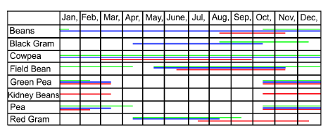
Cropping calendars
Copping calendars varied between villages, between farmers within villages and between crops. Farmers attributed the variation to uncertainty of seed supply and reported that they sowed seed when it was available to them. It was suggested that subsidized seed supply was erratic and that the distribution of centrally supplied seed was frequently delayed. However, farmers also reported that they lacked knowledge in relation to optimum cultivation times for legumes. The high variation in cropping calendars supports statements that optimizing production though sowing and harvesting is hampered by seed availability and there may be opportunities to improve production by harmonizing cultivation with appropriate growing conditions if a reliable seed supply could be secured.
A less tractable impact on legume production was the necessity to prioritize economically important crops. Legumes are generally cultivated during the cropping windows that occur when rice and aubergines (both important in the local economy) are not grown.

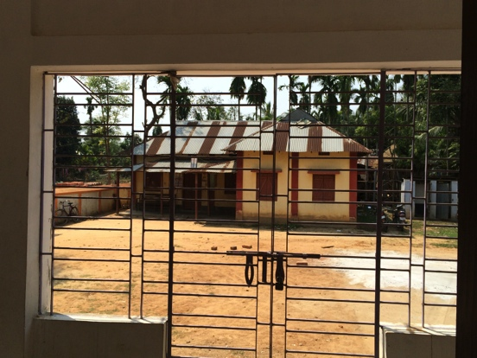
Conclusions
Farmers were aware that legumes are a nutritious component of the diet and legumes were included in numerous local recipes. However, farmers remain to be convinced that legumes could be part of the solution to soil fertility issues and they are not a priority crop. In order to increase legume production three key obstacles need to be overcome.
1. Limits to knowledge: The utility of legumes in increasing soil fertility could be usefully explored experimentally; the interest shown by survey participants suggests that participatory trials are likely to be well received. Our study suggests that a further focus should be on water management as this was cited as a major barrier to production. Furthermore farmers expressed concern over lack of husbandry skills that could be addressed through training. 2. Market priorities: The least tractable of the barriers to increased legume production is the high value for crops such as rice and aubergines, which leads to a lack of prioritization of legumes in the cropping the calendar. In addition to opening market opportunities for selling legumes it is necessary to remove hurdles in the supply chain. 3. Supply chain barriers: A reliable supply of good quality seed is essential, something which farmers assert is currently lacking in the distributions system. Furthermore legumes require processing to maximize value and access to processing units is crucial but currently lacking.
References
The National Survey of Household Income and Expenditure.
Arlappa, N., Balakrishna, N., Laxmaiah, A., Brahmam, (2007) Pattern of indigenous vegetables and legumes consumption in rural India, 1ST INTERNATIONAL CONFERENCE ON INDIGENOUS VEGETABLES AND LEGUMES PROSPECTUS FOR FIGHTING POVERTY, HUNGER AND MALNUTRITION, pp. 505-508.
Bernard, H.R. (2002) Research Methods in Anthropology. Altamira Press, Walnut Creek, CA.
Crews, T.E., Peoples, M.B. (2004) Legume versus fertilizer sources of nitrogen: ecological tradeoffs and human needs. Agriculture, Ecosystems & Environment 102, 279-297.
Ghosh, P.K., Bandyopadhyay, K.K., Wanjari, R.H., Manna, M.C., Misra, A.K., Mohanty, M., Subba Rao, A. (2007) Legume Effect for Enhancing Productivity and Nutrient Use-Efficiency in Major Cropping Systems– An Indian Perspective: A Review. Journal of Sustainable Agriculture 30.
Sutherland, W.J., Gardner, T.A., Haider, J., Dicks, L.V. (2013) How can local and traditional knowledge be effectively incorporated into international assessments? Oryx 48, 1-2.
Tengö, M., Malmer, P., Brondizio, E., Elmqvist, T., Spierenburg, M., (2013) The Multiple Evidence Base as a framework for connecting diverse knowledge systems in the IPBES. Discussion paper 2012-­‐06-­‐04. Stockholm Resilience Centre (SRC), Stockholm University, Sweden, http://www.stockholmresilience.org.
Traore, M., Thompson, B., Thomas, G., (2012) Sustainable nutrition security: Restoring the bridge between agriculture and health, in: FAO (Ed.). FAO, Rome.

https://www.wfp.org/food-assistance/kind-food-assistance/wfp-food-basket (accessed 16/11/2016)
http://www.ipga.co.in/pulses-trade-import-export (accessed 16/11/2016)
http://www.ncaer.org/study_details.php?cID=4&pID=48 (accessed 28/02/2017)

